**I) Challenges in Writing the Program:**

**Complex Logic:** The program includes complex booking rationale, including imperatives connected with room limits, favored facilitators, and different elements. Dealing with these requirements and guaranteeing they are accurately applied is a difficult undertaking.

**Genetic Algorithm:** Implementation: Implementing a genetic algorithm, with selection, crossover, and mutation operations, can be complex and may require fine-tuning for optimal performance.

**Debugging:** With many activities, rooms, facilitators, and other parameters, debugging potential issues in the program, such as infinite loops or incorrect logic, can be time-consuming.

**Tuning Parameters:** Setting parameters such as population size, mutation rate, and the number of generations requires experimentation to find the right balance.

**ii) Evaluation of the Generated Schedule:**

The schedule generated by your program is based on the fitness function you've defined, which attempts to optimize various factors. However, whether the schedule is acceptable or not depends on specific requirements and constraints of the real-world scenario.

**Odd Placements:** The program might produce schedules that are optimal according to the defined fitness function but could still be considered odd or out of place from a real-world perspective. For example, certain activities might be scheduled in back-to-back time slots or in rooms that are distant from each other.

**Room and Facilitator Load:** While the program considers room capacities and facilitator hundreds, it might be useful to have extra best-grained manipulation over how these factors are prioritized. For instance, certain activities are probably extra bendy in terms of room length, at the same time as others require a preferred facilitator

**Complexity of Constraints:** The program's constraints are quite complex and sometimes interrelated. It's essential to strike a balance between them and potentially introduce additional rules to fine-tune the schedule.

**iii) Improvements and Changes:**

**Fine-Tune Fitness Function:** Consider making the health feature greater bendy to deal with additional guidelines or constraints specific in your scheduling trouble. For instance, you can introduce penalties for consecutive sports in distinctive homes or modifications primarily based at the order of activities.

**Advanced Genetic Algorithm Techniques:** Investigate greater advanced strategies for genetic algorithms, consisting of distinct selection techniques crossover techniques, and mutation strategies. This may want to doubtlessly improve the look for higher solutions

**Visualization:** Implement a visualization component to view the generated schedules graphically. This would help in identifying any oddities or patterns in the schedules.

**User Interface:** If this program is intended for use by non-technical users, consider developing a user-friendly interface for inputting constraints and visualizing schedules.

**iv) Other Considerations:**

**Scalability:** Ensure the program can handle larger datasets without performance issues, as the number of activities, rooms, and facilitators increases.

**Parallelization:** Consider parallelizing the genetic algorithm to speed up the optimization process.

**Documentation**: Provide detailed documentation for the program, including how to input constraints and use it effectively.

**Testing:** Rigorous testing is crucial to verify the correctness of the program and the quality of the schedules it produces.

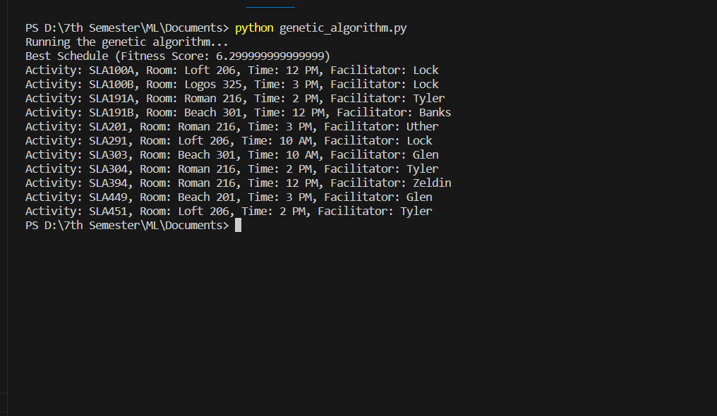**OUUPUT**